HBCU Initial Data Draw

Dick Startz

November 2020

The eventual goal is to write a short piece, around 1,000 words maybe, about interesting things about HBCUs. I’d like to begin by putting together data on their racial composition, graduation rates, endowments, and perhaps how much of their financing comes form the federal government. Since this is initially exploratory, we might want to begin by putting together a lot of data and then taking subsets as needed.

The basic data source is IPEDS, <https://nces.ed.gov/ipeds/use-the-data>. IPEDS has a bunch of files which are mostly one line per institution. (Although some of the files have one line for each program in an institution, which can be confusing.) Under Survey data on the right, Select download option choose Complete Data files. This gives a page looking like

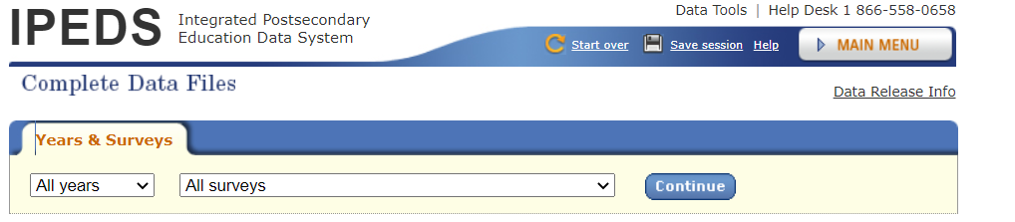

Initially, just take the most recent year and say all surveys

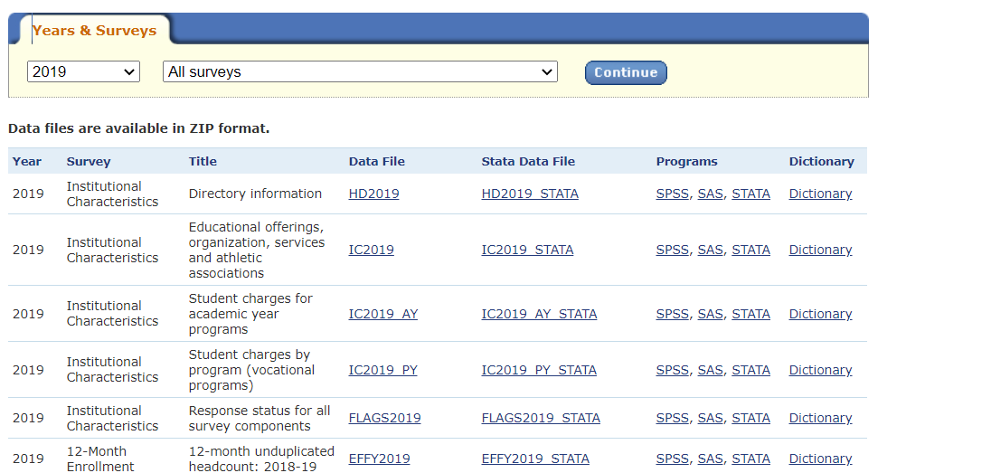

For each relevant survey we want the Dictionary (which is an Excel file telling what variables are in that file), the Stata datafile (which is actually a \*.csv file containing the data), and the Stata program file (a \*.do file). The trick is to download all three files into a directory, start Stata, changing the working directory to that directory, run the do file. This gives a Stata \*.dta file. (I can arrange access to Stata if you don’t already have access.) Then use the haven package in R to read in that \*.dta file.

The main trick is that every file has an identifier UNITID for each school, allowing the files to be joined. However, some files have multiple observations for each school, generally using a variable CIPCODE to identify each subprogram. We generally want CIPCODE 99, which is the grand total. We also only want to keep schools that are 4-year or more, variable ICLEVEL in file HD.

As a start, let’s get the data out of files HD2019, IC2019, C2019A, GR2019, GR2019 PELL SSL, and F1718 F1A and F1718 F2. (or maybe just start with the first two.) Then, in addition to creating the file, what can be said about the availability of remedial services in HBCUs versus other schools.